Section 6 – Evaluation

SIMP is now finished, there will now be final evaluation on the program

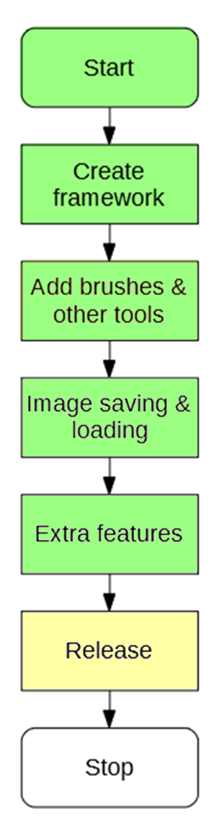

# 6.1 Criteria Fulfilment

## Starting Window

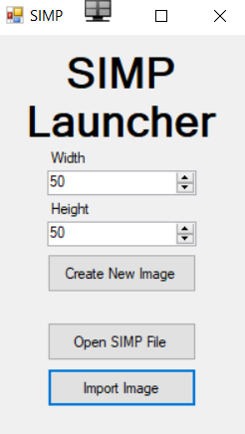

Allows you import an image of varying types

**Fulfils: C2**

Allows you to open an existing SIMP File

**Fulfils: C5**

Allows you to define what size you want

**Fulfils: C1**

## SIMP Open File Browser

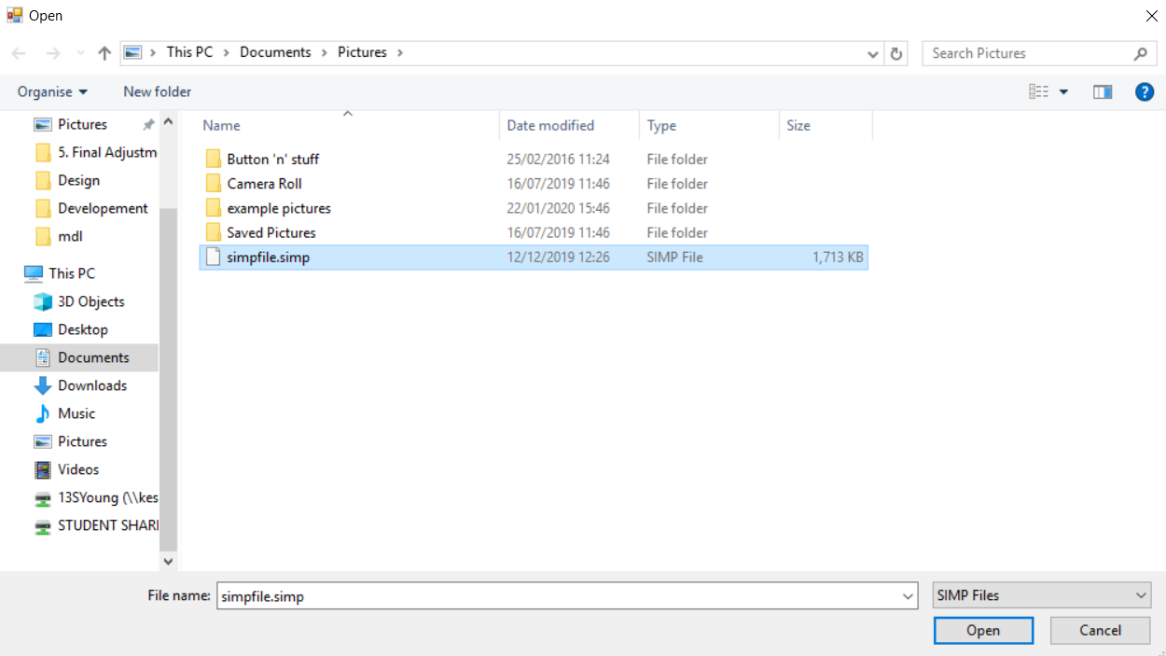

Validation such that only .simp files can be opened

An existing file in the file browser

**Fulfils: C5**

## SIMP Import Image Browser

An image file that can be imported

**Fulfils: C2**

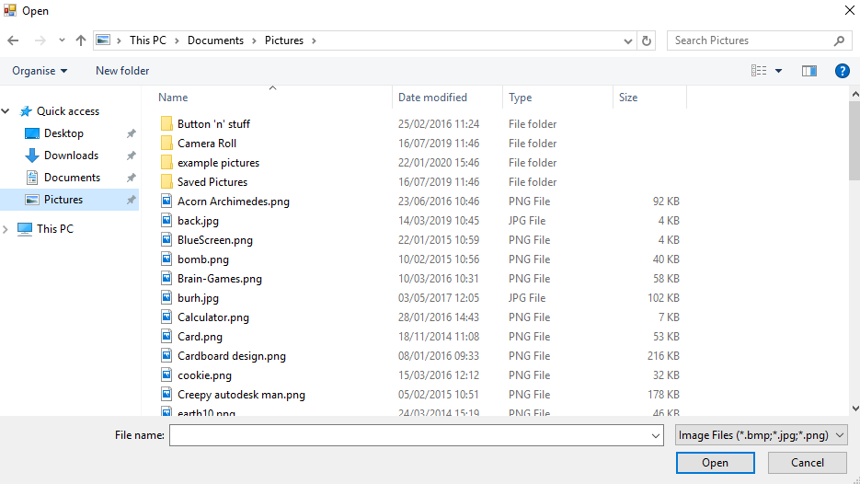

Has options to import both PNG and JPEG

**Fulfils: C5**

Validation such that only certain image files can be opened

## Main Workspace

Eyedropper tool

**Fulfils: B11**

Image viewer

**Fulfils: B1**

Colour of the pen can be changed

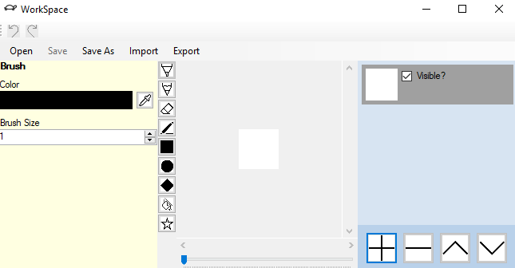

Layer navigator

**Fulfils: C2**

Brush size can be varied

**Fulfils: A1**

Open existing proprietary file format

**Fulfils: C1**

Image is more zoomed in than previously

**Fulfils: B9**

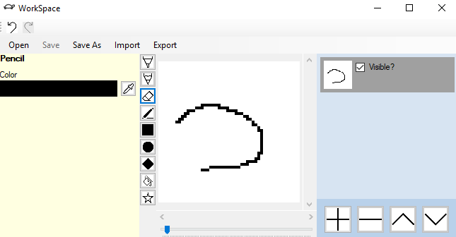

Edge of the line has a hard edge, no transparent

**Fulfils: A2**

Zoom bar to allow zoom to be changed

Add, remove, shift up and shift down layer buttons.

Single pixel pencil tool for fine work

**Fulfils: A5**

Layer tool showing two layers, with the top one currently selected

Overwrite currently saved file

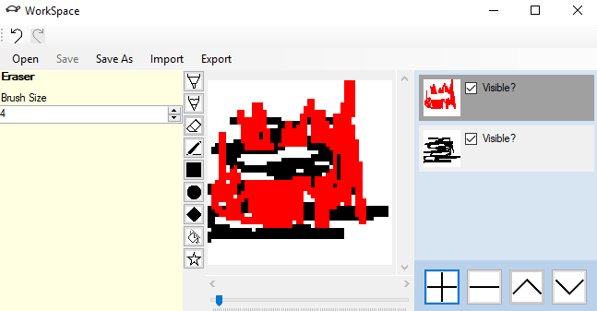

Eraser has made pixels transparent, so you can see layer below

**Fulfils: B8**

Eraser tool for erasing the upper layer, revealing lower layer

**Fulfils: A6**

Save current workspace to a proprietary file

**Fulfils: C5**

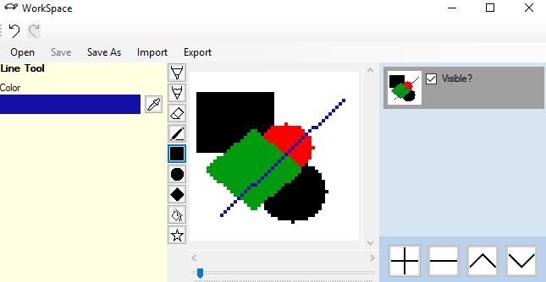

Shapes a drawn using pixels and not using vector structure

**Fulfils: B2**

Shape creation tools for making shapes

**Fulfils: A3**

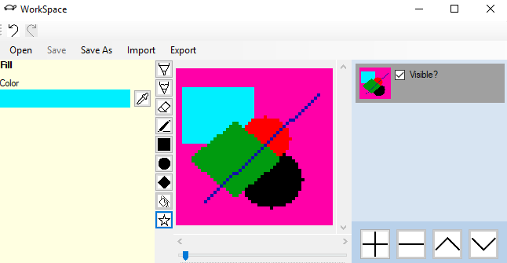

Import from a PNG or JPEG file into workspace

**Fulfils: C2**

Fill tool that fills an area

**Fulfils: A4**

Image has been filled in a few places

Export image to a PNG or JPEG

**Fulfils: C3**

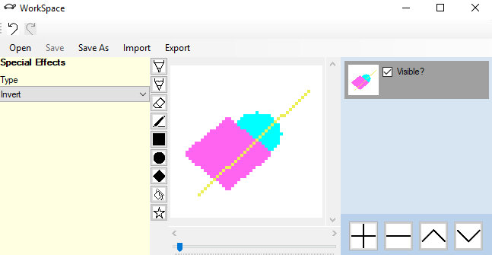

Shape creation tools for making shapes

**Fulfils: B12**

Image has been inverted from previous

SIMP Export Image Browser

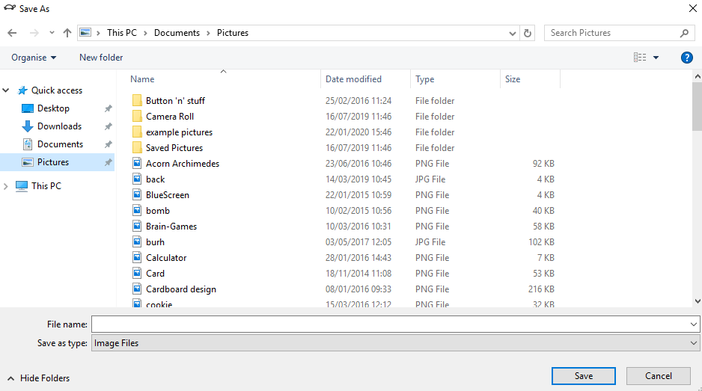

Allows user to input name of file to export, and type (PNG or JPEG)

## SIMP RGB Picker

Colour strip so user can define hue of colour

**Fulfils: B3**

Colour square to allow user to define shade of colour

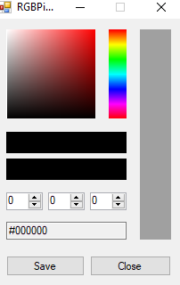

R, G and B input to enter RGB code

**Fulfils: B4**

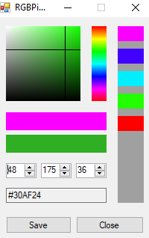

RGB Code

Previous colour selector allows user to select a colour they used before

Crosshair gives user an indication of what colour they are using

Current RGB colour

Previous RGB colour

## Full Criteria Fulfilment Diagram

|  |  |  |
| --- | --- | --- |
| **Feature** | **Fulfilled?** | **Code** |
| Section A - Brushes | | |
| Variable brush width | Yes | A1 |
| Hard brushes | Yes | A2 |
| Shape creation tools | Yes | A3 |
| Fill (bucket) tool | Yes | A4 |
| Single pixel pencil | Yes | A5 |
| Rubber | Yes | A6 |
| Section B – Other editing tools | | |
| Image viewer | Yes | B1 |
| Bitmap image editor | Yes | B2 |
| RGB colour picker | Yes | B3 |
| RGB direct input | Yes | B4 |
| Layer system | Yes | B5 |
| Rectangle selection tool | No | B6 |
| Magic selection tool | No | B7 |
| Transparent pixels | Yes | B8 |
| Zoom in (no zoom out) | Yes | B9 |
| Text | No | B10 |
| Eyedropper tool | Yes | B11 |
| *Image effects* | Yes | B12 |
| *Rotating Images* | No | B13 |
| *Clipping masks* | No | B14 |
| Section C – File System | | |
| Creating a new image | Yes | C1 |
| Importing images | Yes | C2 |
| Exporting images | Yes | C3 |
| Supporting PNG and JPEG | Yes | C4 |
| Saving and loading from a proprietary format | Yes | C5 |
| Section D – Usability | | |
| Program should be stable and not crash. | Yes | D1 |
| Program should be easy to use | Yes | D2 |
| Features should be easily accessible | Yes | D3 |